Deployment of Azure Infrastructure

  - Create Resource Group and Virtual Network
  - Create the Resource Group – Chaitra_RG_Assignment at EastUS region and create First VNET Chaitra-VNET-Core with CIDR 192.168.0.0/16 at EastUS region.
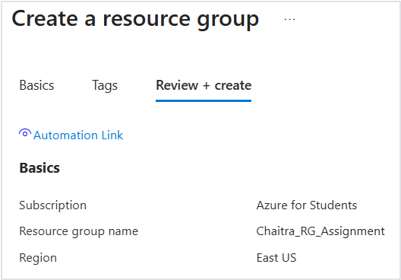

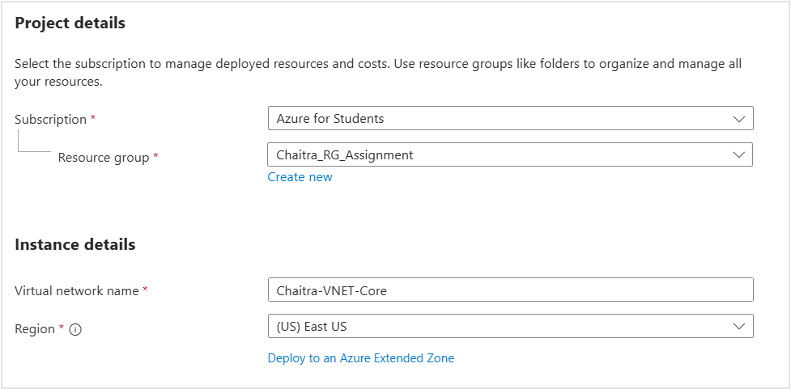

Click on Next to Assign CIDR with 192.168.0.0/16 and create two subnets as:

▪ WebTier subnet: 192.168.10.0/24
▪ MgmtSubnet subnet: 192.168.20.0/24
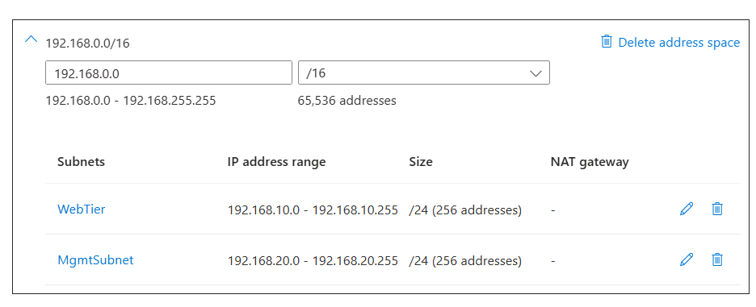

Click Next to review and create
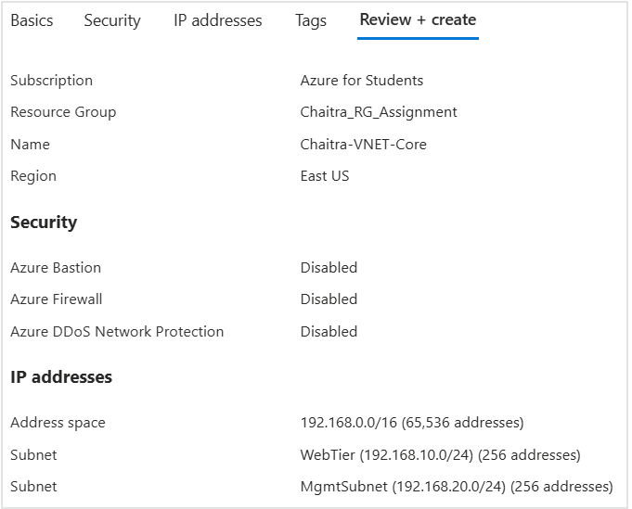

  - Create the Second VNET in the Name of Chaitra-VNET-Services with CIDR 10.10.0.0/16
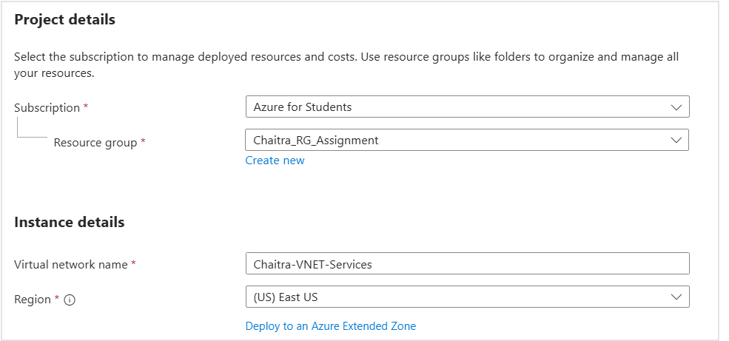

Click on Next to Assign CIDR with 10.10.0.0/16 and DataSubnet subnet: 10.10.1.0/24
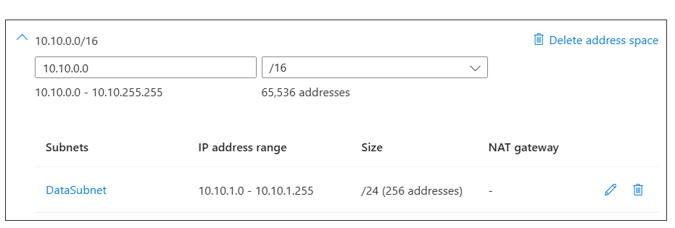

Click Next to review and create

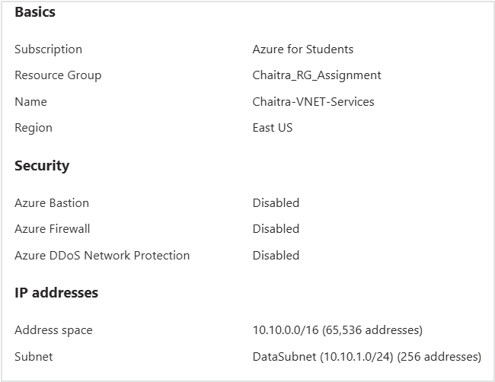

Once the Deployment of both VNET is done, go under the VNets to check Subnets and confirm.

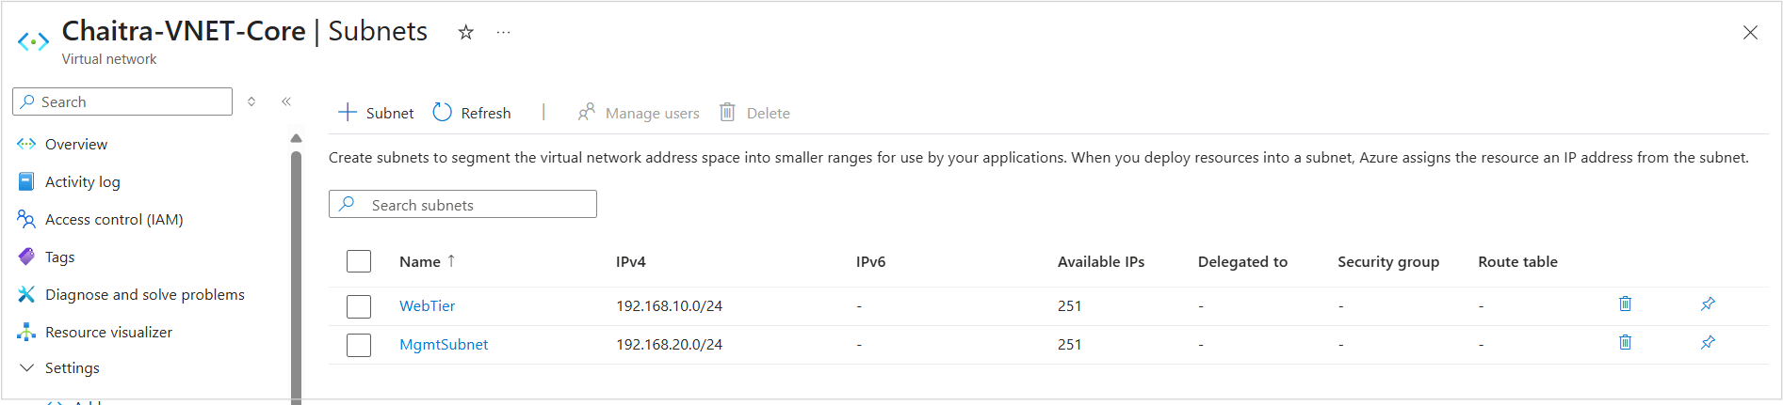
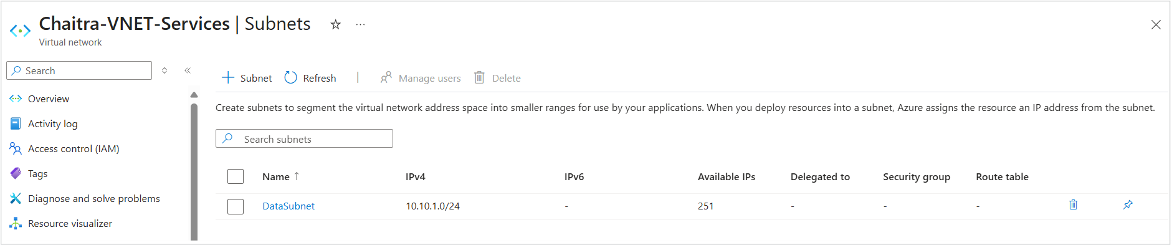

- VNet Peering
To Establish bidirectional peering between the two VNets.
- We need to select any one Vnet that is created.
- Then select Peering option from the service menu.
- Click on Add to Peer a Vnet
- Here peering name is given as “VNETCore-VNETServices”

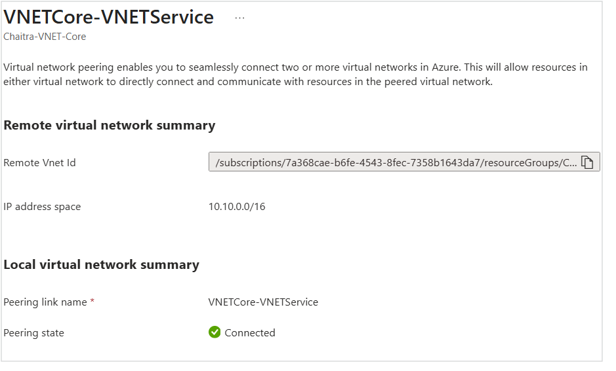

- Creating VMs

- Create “Chaitra-MgmtVM” in MgmtSubnet:
- Selected Windows Server 2022,
- RDP access only from current public IP

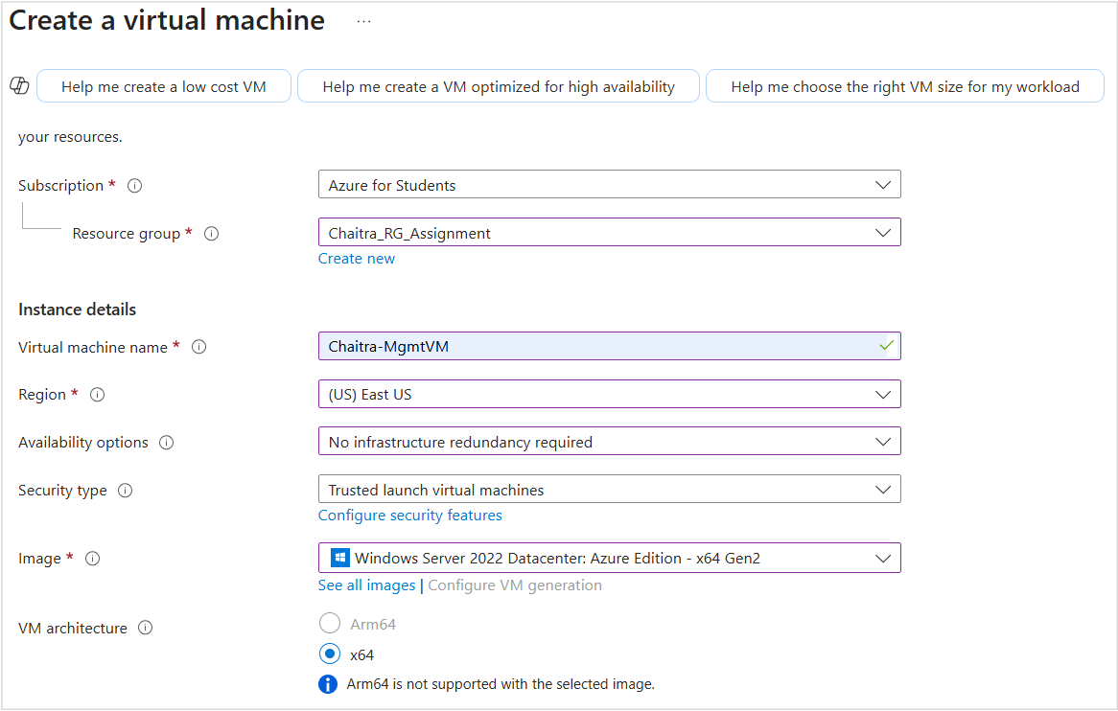
- Click next for selecting mgmt-subnet and new public ip.
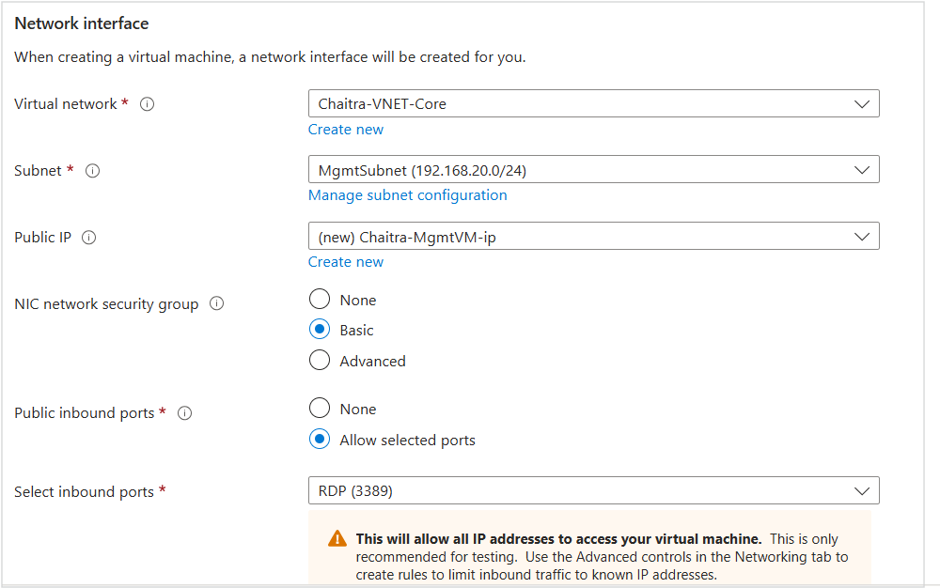

- Review and create.

Access the VM using Public ip via RDP

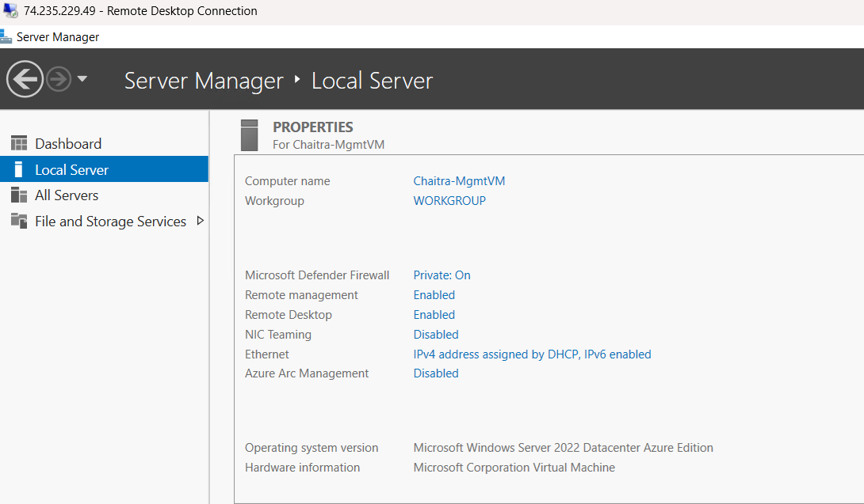

Create second VM Ubuntu with NGINX, No ssh and allow Http and https

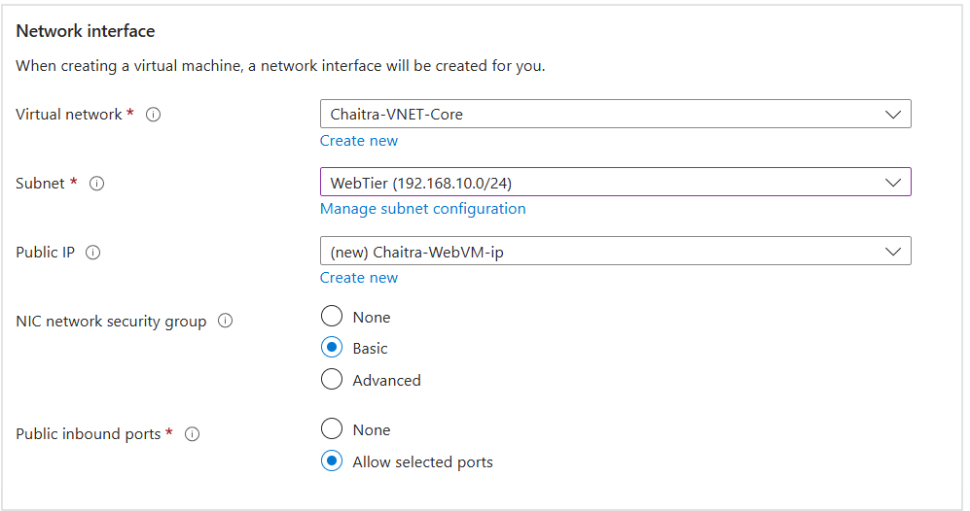
- Click next to select webtier subnet and create public ip
- Click on advanced tab to add Custom script data and review and create.
- Below is the script

#!/bin/bash
# Update package list
sudo apt update
# Install nginx
sudo apt install nginx -y
# Start nginx
sudo systemctl start nginx

After the deployment of Ubuntu vm, note the public ip of the VM to access the nginx default website via browser. (172.172.176.8)
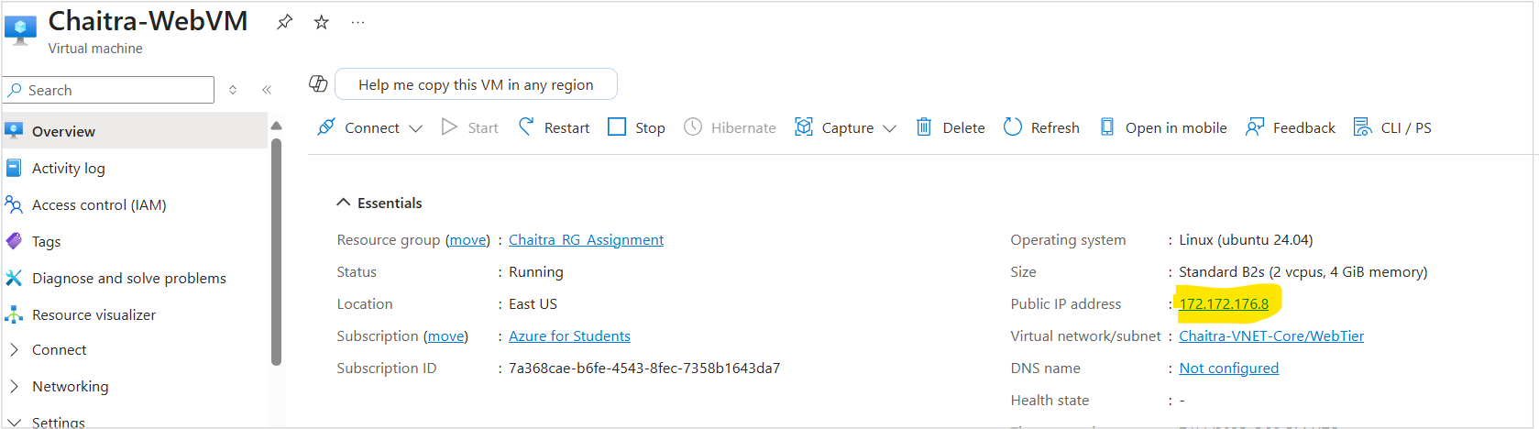

Go to NSG “chaitra-webvm-nsg” and add inbound security rules -> add ->allow http(80) and https(443)
Lets access the nginx default website from a browser via public ip. <172.172.176.8>

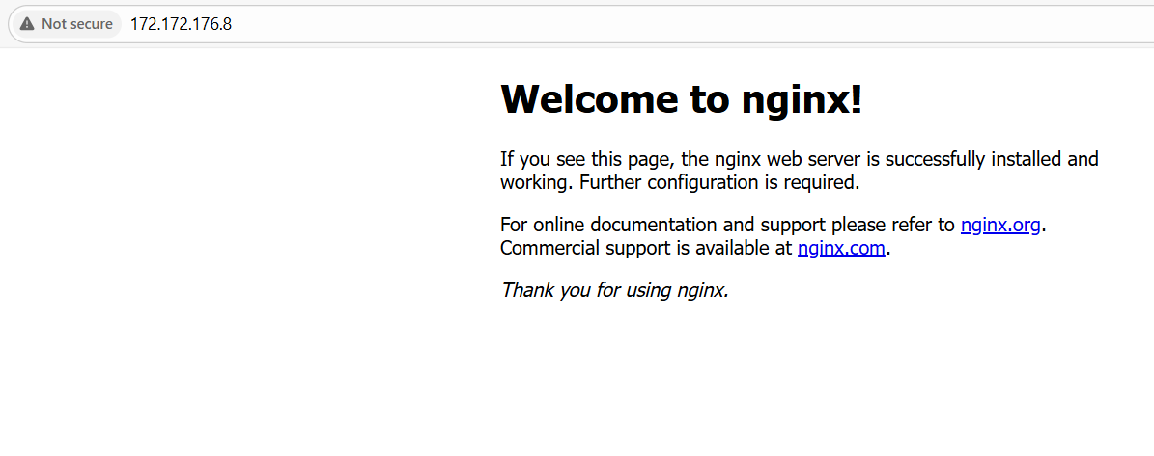
Create third VM(Ubuntu), without public ip
- In the networking tab, disable public ip and select the Vnet as Chaitra-VNET-Services and the subnet DataSubnet

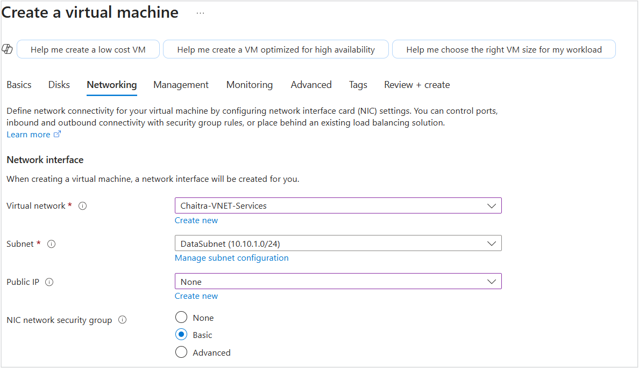
- Review and create.

4 Creating NSG
Go to NSG settings of mgmtvm ->click inbound security rules ->add
Select source ip and enter public ip, select destination port as 3389(RDP) and ADD.

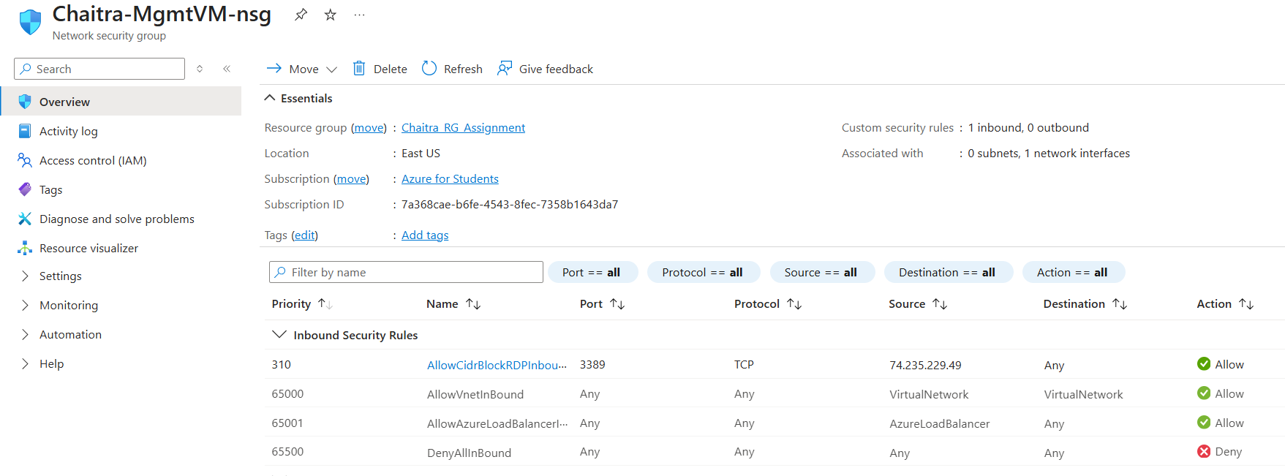

Go to Ubuntu(nginx) NSG settings and allow only http and https

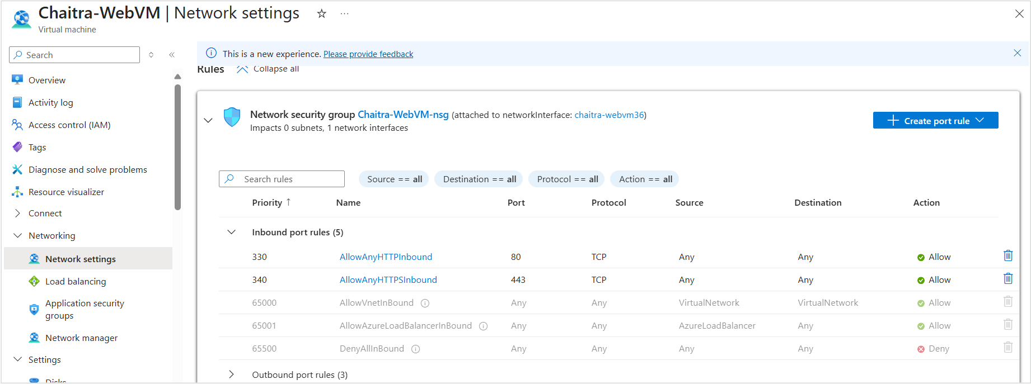

Data VM NSG settings

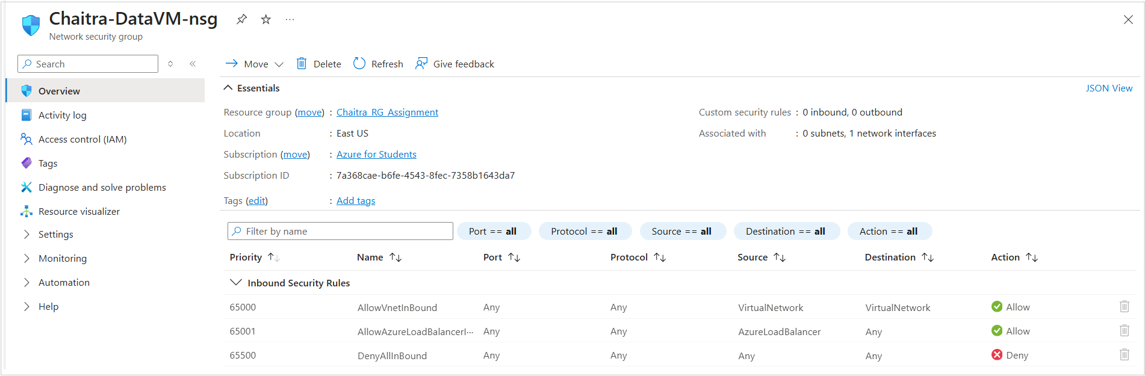

FINAL OUTPUT

- Accessing Chaitra-MgmtVM via RDP by using public ip
- Enter Username and Password to login, login successful
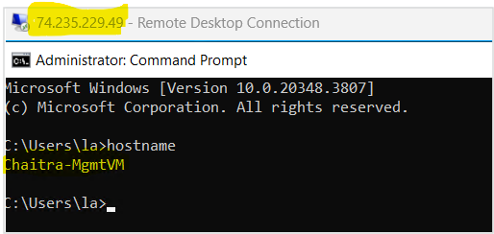
- SSH access to Chaitra-WebVM is performed internally from Chaitra-MgmtVM using the VM's private IP address (192.168.10.4). This confirms that internal connectivity is functioning correctly, while public SSH access remains restricted as per the configured NSG rules.
- Open Poweshell in MgmtVM RDP and Type the command ssh la@192.168.10.4, enter the password and login
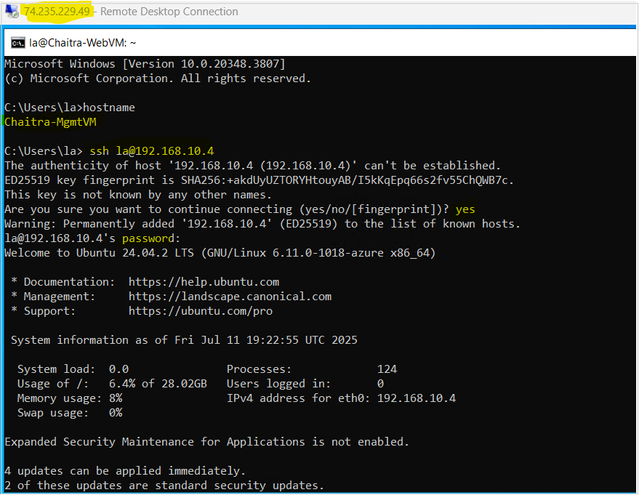

- SSH access to Chaitra-DataVM is performed internally from Chaitra-WebVM using the VM's private IP address (192.168.10.4). This confirms that internal connectivity is functioning correctly via NSG rules.
- Enter the Username and Password for the VM and login

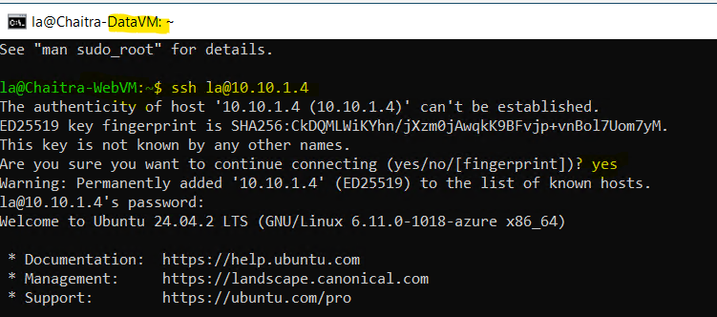

- Accessed DataVM via private ip through SSH from the WebVM.

SSH access to Chaitra-WebVM was successfully tested from Chaitra-MgmtVM using its private IP address, confirming internal network connectivity. Since SSH access is blocked via public IP as per the NSG rules, this validates that access is only permitted through the internal VNet.
Additionally, connectivity from Chaitra-WebVM to Chaitra-DataVM using its private IP was successful, confirming that the Data VM is securely isolated from public networks and accessible only through internal tiers.

